EET-2910
Instrument List & I/O Configuration

Purpose: The purpose of this exercise is to help the student understand the process and importance of creating an Instrument List for a Control System.

Procedure:

- Create an Instrument List (or I/O List) for the Tank Dispenser system.

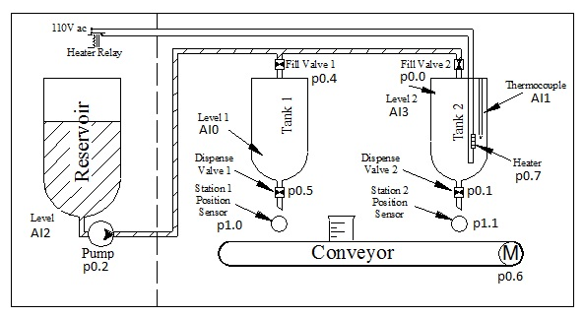

- Create a LabVIEW I/O Configuration for the Tank Dispenser system shown using a USB-6008 Module.
  - Create a While Loop (found under Programming/Structures) for the entire I/O Configuration.
  - Analog Input is 1-5Vdc, (1 Sample on Demand)
  - Digital Input/Output is default configuration (1 Sample on-demand)
- Test each Analog and Digital Point for functionality.

